**Big Mountain Resort - Ticket Price Evaluation**

**Report Summary**

Big Mountain Resort, a ski resort located in Montana, recently installed an additional chair lift to help the distribution of visitors across the mountain. However, the additional chair increases the resort's operating costs by $1,540,000 for the season. To accommodate for the additional cost, Big Mountain Resort has been charging a premium above the average resorts in the market segment, but this approach does not inform the resort if (and which) of its facilities are more valued compared to others. The resort would like guidance on how to select a better value for its ticket price to get the greatest financial return on its services and to earn a profit this year to account for the additional operating cost of a chair lift.

Big Mountain Resort **currently charges $81**. In order to find the most optimal ticket price, I went through the process of wrangling, exploring, pre-processing, and modeling the data available on U.S. ski resort ticket prices. As a result of the in-depth analysis, I found that the most important features impacting the ticket price for resorts across the U.S. (excluding Big Mountain) are: the number of fast quads, runs, snow making machines, and vertical drops at each resort. When stacking Big Mountain against the other resorts in the context of these features, Big Mountain landed on the higher end, if not highest end, for the amount of these features.

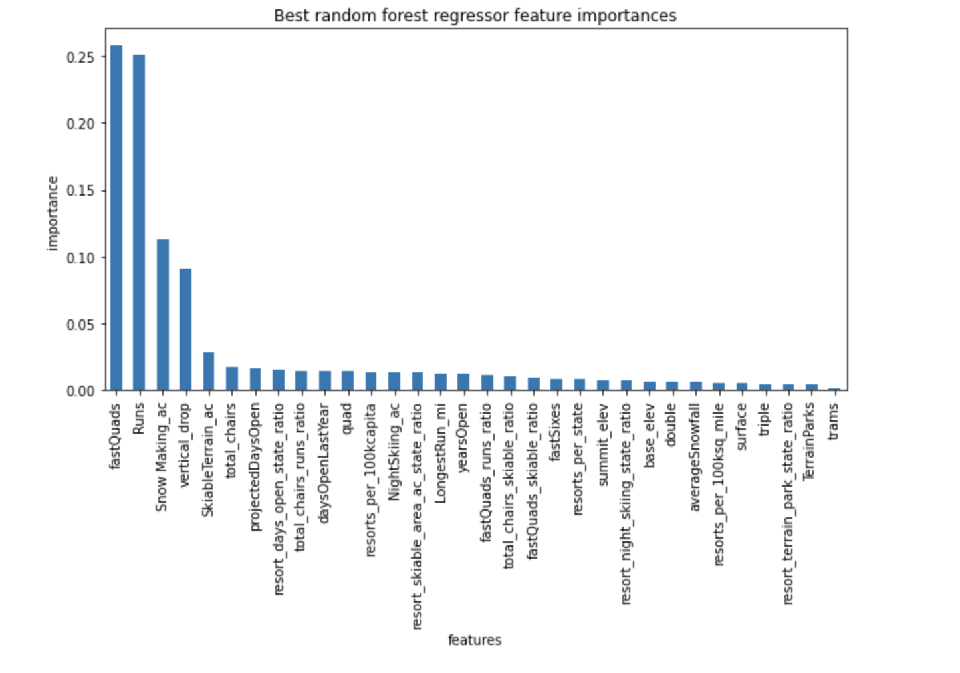

|  |  |  |  |  |
| --- | --- | --- | --- | --- |
|  |  |  |  |  |
|  |  |  |  |  |

*Plots of how Big Mountain Resort’s features compares to U.S. resorts*

Using a random forest model -- which was found to be the best predictor for ticket price -- I was able to determine that Big Mountain Resort’s ticket price, based on the value of its features, should be at **around $95.87 per ticket** (room for error is around $10). However, there are a lot of factors to take into consideration when looking at this price. My model assumes other resorts are priced correctly according to the market and consumer demand, but there is always potential we are missing key data or that other resorts are charging overpriced or underpriced tickets.

The most optimal solution for accommodating the additional operating costs of the new chair lift at Big Mountain Resort is simply to increase the ticket price to more accurately represent its true value. But, there are a couple other scenarios to consider to help Big Mountain Resort seek the greatest financial return on its ticket prices.

Here is additional data on how the four most important features impact ticket prices, and different scenarios to consider:

1. Closing one run at Big Mountain Resort does not impact ticket price at all, but closing two and subsequently three runs reduces ticket prices, and, therefore, revenue. And if Big Mountain closes three, it may as well close four and five because there isn’t further loss in ticket value.
2. Adding one vertical drop to the resort increases support for ticket price by $8.61, which over the season, could be expected to amount to $15,065,471 (based on if 350,000 visitors per season, and, on average, visitors ski for five days).
3. Adding one vertical drop and two acres of snow making increases support for ticket price by $9.90, which over the season, could be expected to amount to $17,322,717 (based on if 350,000 visitors per season, and, on average, visitors ski for five days).
4. Increasing the longest run by .2 miles and guaranteeing its snow coverage by adding four acres of snow making capability makes no difference in support for an increased ticket price whatsoever.

Another potential solution aside from raising the ticket price to match its true value in the market, is to embark on scenario two and add a vertical drop and additional chair lift to further increase ticket price. However, operating and installation costs must be considered in this scenario to ensure profitability and the highest return on investment.